DYLAN M. MORTENSEN — ITEM PACKET
Blanket (her bed) + jacket (spare room) | Reports 35 and 36 | Nowlin correspondence
STAND-OUT: RYLENE NOWLIN WENT TO BILL THOMPSON
6/14/2023 — ISPFS DNA analyst Rylene Nowlin called prosecutor Bill Thompson and Ashley Jennings. She was not logging a routine handoff. She was pissed that Det. Talbott BlueStar'd Dylan's coat and blanket BEFORE any lab work.
Why she escalated to the prosecutor (not just the detective):
1. Those two items were on defense expert Matt Noedel's list. Defense wanted private-lab testing.
2. Talbott sprayed BlueStar first. Nowlin: that is NOT the ideal first step on clothing / a blanket.
3. BlueStar can INHIBIT lab o-tol / pheno. Lab negatives after BlueStar do NOT prove no blood.
4. Liquid BlueStar DILUTES stains/DNA. Dilute-blood DNA studies are less certain.
5. Coat fluorescence may have been the ZIPPER METAL, not blood.
6. Reaction photos did not turn out. Pre-BlueStar photos: unsure if Moscow even took them.
7. Items had already been RELEASED BACK TO DYLAN as personal property. Court then ordered them back into custody. Washed while out? They did not know.
Source: ISPFS Case Correspondence, M2022-4843, page 44 of 57 STORY log. Analyst Rylene Nowlin. Calls 6/8/23 (Talbott) and 6/14/23 (Thompson/Ashley, then Gilbertson/Talbott).

1. Item chart
Item | Lab / MPD # | Where / release | Testing outcome
Pink VS blanket (hearts / white sherpa) | ISP 132 / MPD 723. 132.1 and 132.2. Extract = Item 134 | FROM HER BED. Personal item released back to Dylan, then court ordered released scene items back into custody. Unknown if washed. | Talbott BlueStar +. Wilt o-tol + on Side A (132.1 cut to DNA; 132.2 weak + / consumptive). Report 36: 132.1 STR matches Item 19 known (Dylan) at 7.74 x 10^25.
Light green Wild Fable hooded jacket, size M | ISP 133 / MPD 729 | FROM THE SPARE ROOM. Same personal-item release, then court-ordered back. Unknown if washed. | Talbott BlueStar field +. Nowlin: zipper metal may fluoresce. Wilt 20/20 o-tol NEGATIVE. Report 35: no blood indicated. No DNA. Back to vault.

Nowlin timeline
6/8/23 Talbott: defense wants private lab. He already BlueStar'd. Coat + blanket from Dylan both reacted. He wants foreign DNA. Nowlin: BlueStar first on these items is wrong; I have to talk to DNA unit.
6/14/23 NOWLIN CALLS BILL THOMPSON AND ASHLEY. Items are Noedel's list. D2 had Talbott presumptive-test first. She spells out the science limits and that lab negatives after BlueStar cannot be read as no blood.
6/14/23 later Gilbertson/Talbott: photos before spray unsure; reaction photos failed; both sides of blanket and in/out of coat sprayed; released to Dylan then court-ordered back; washed? unknown.

2. Nowlin correspondence (page 44 of 57)
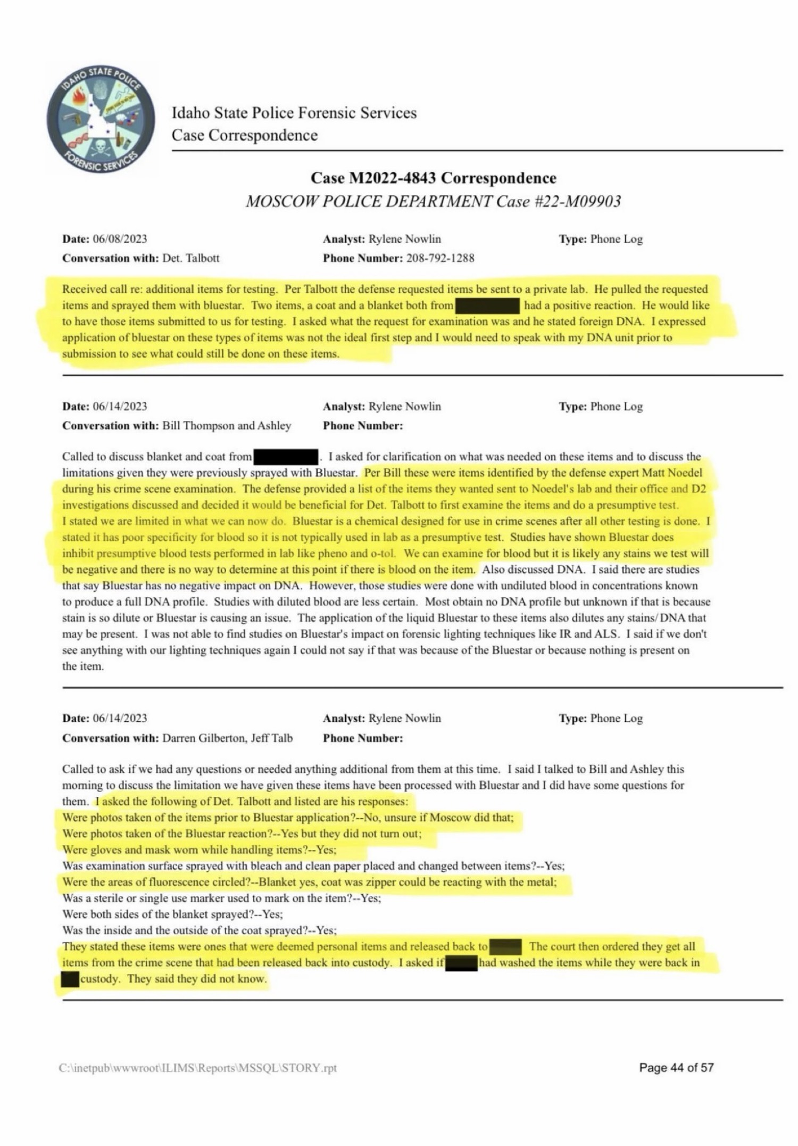

3. Report 35 — Wilt screening (issued 7/7/23)
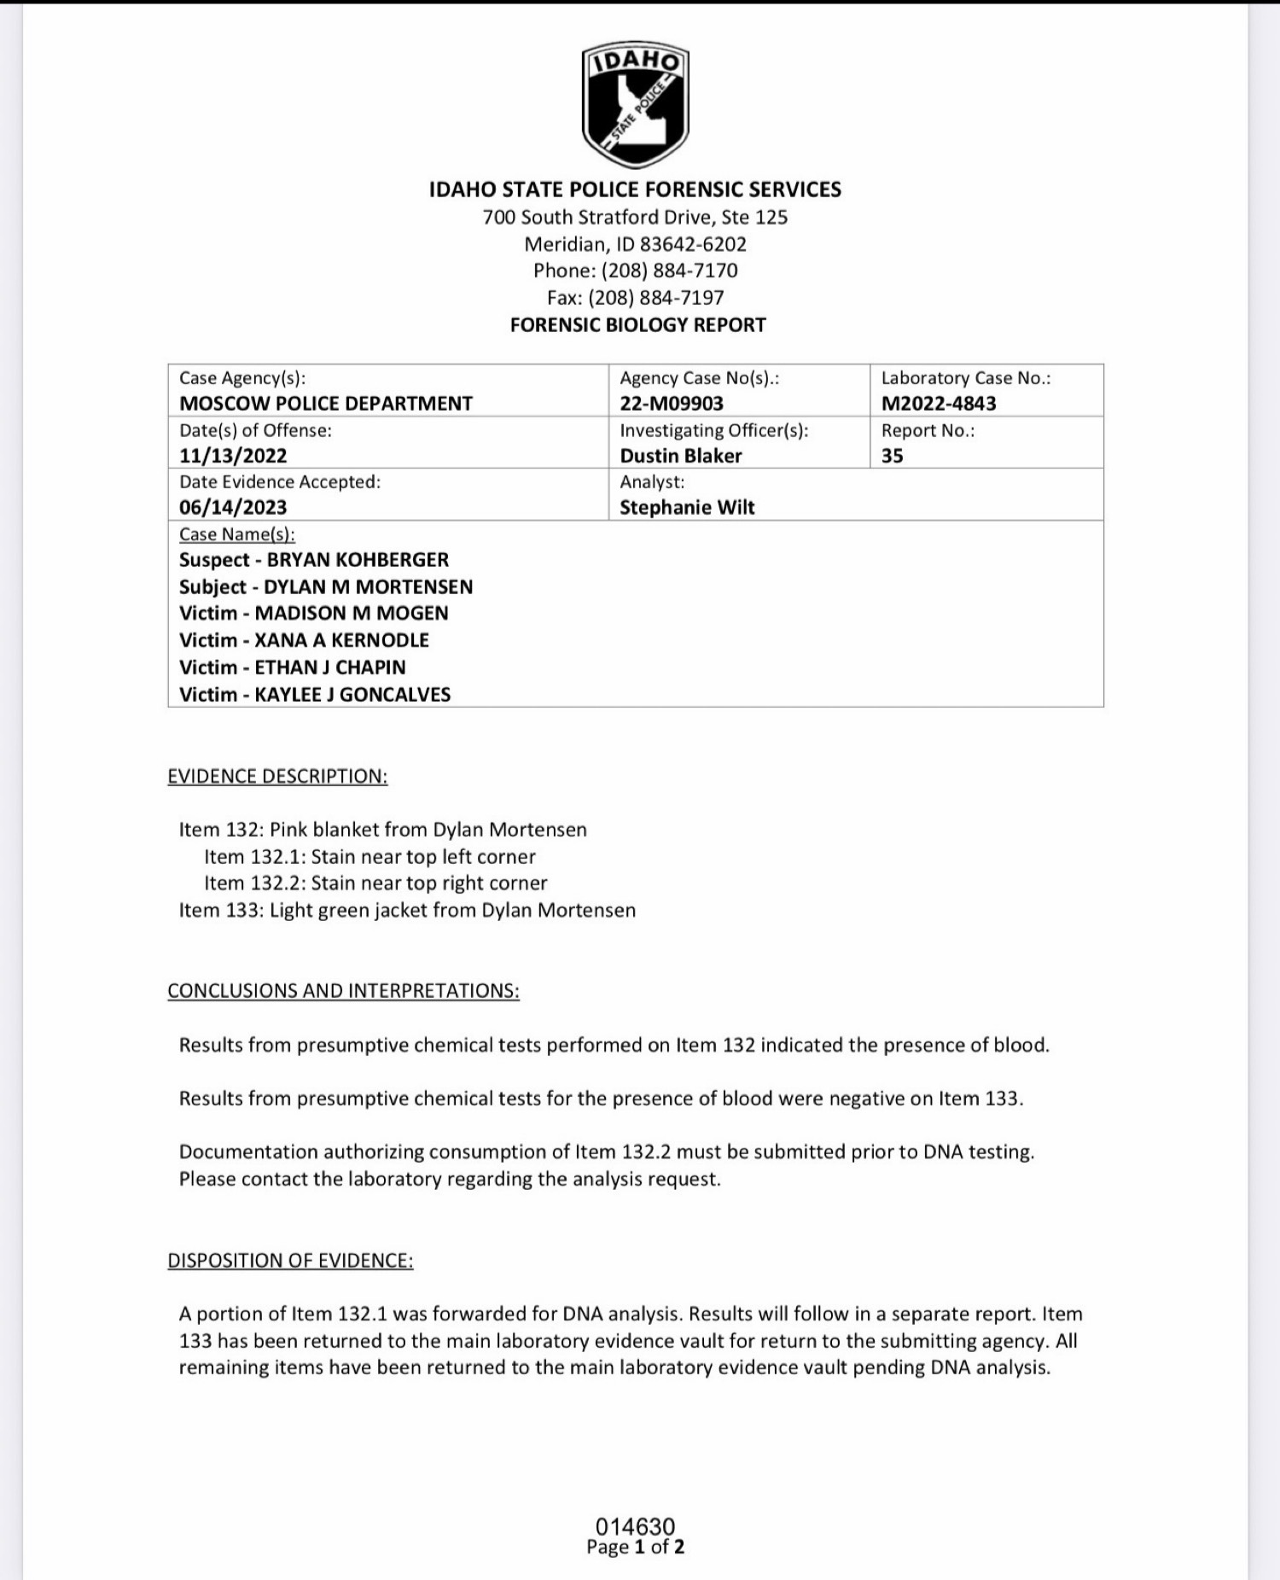

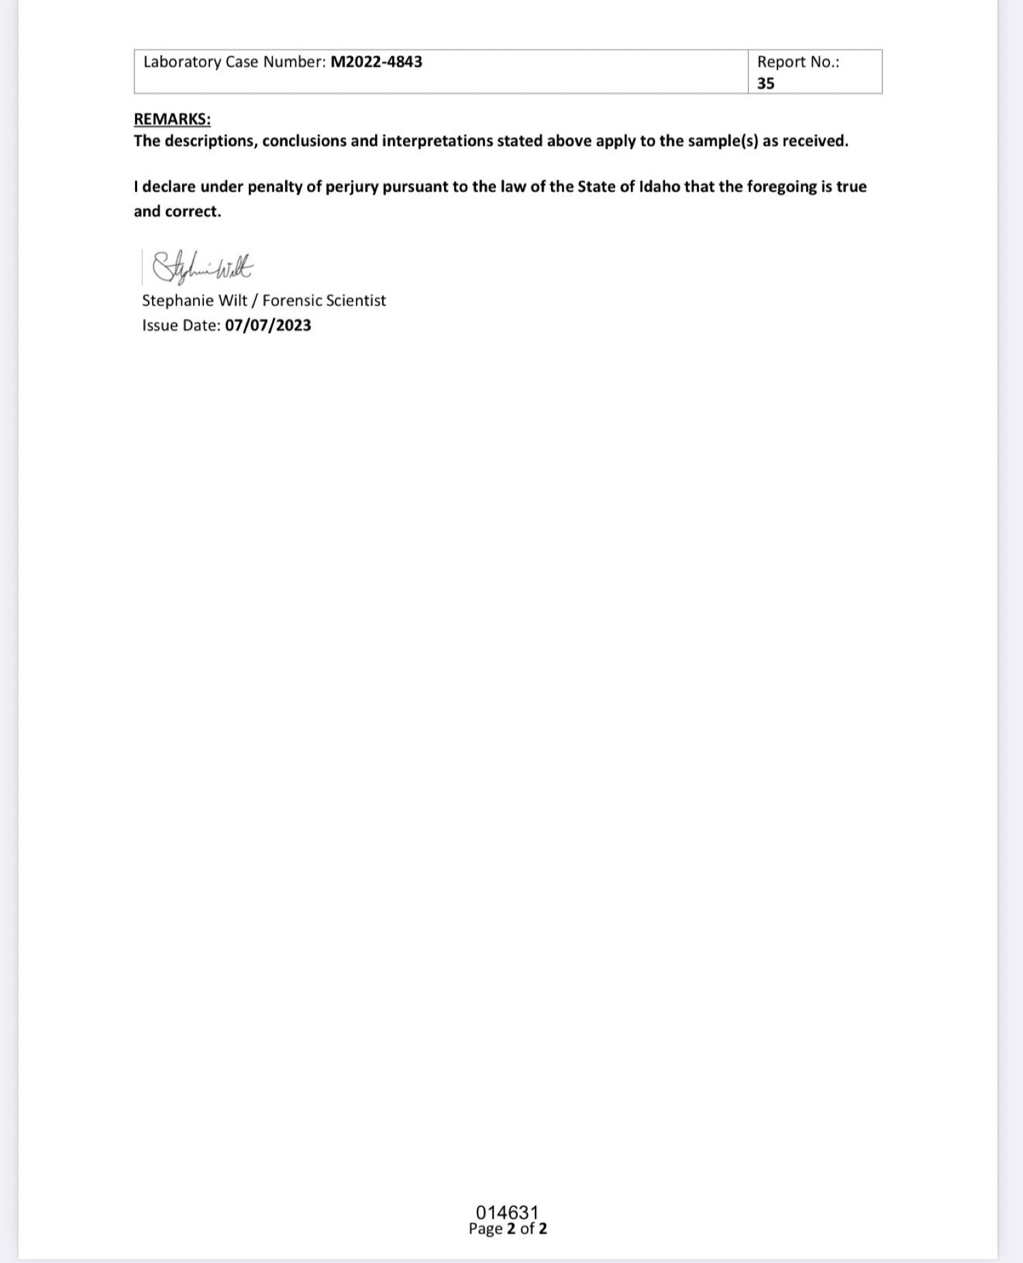

4. Wilt notes
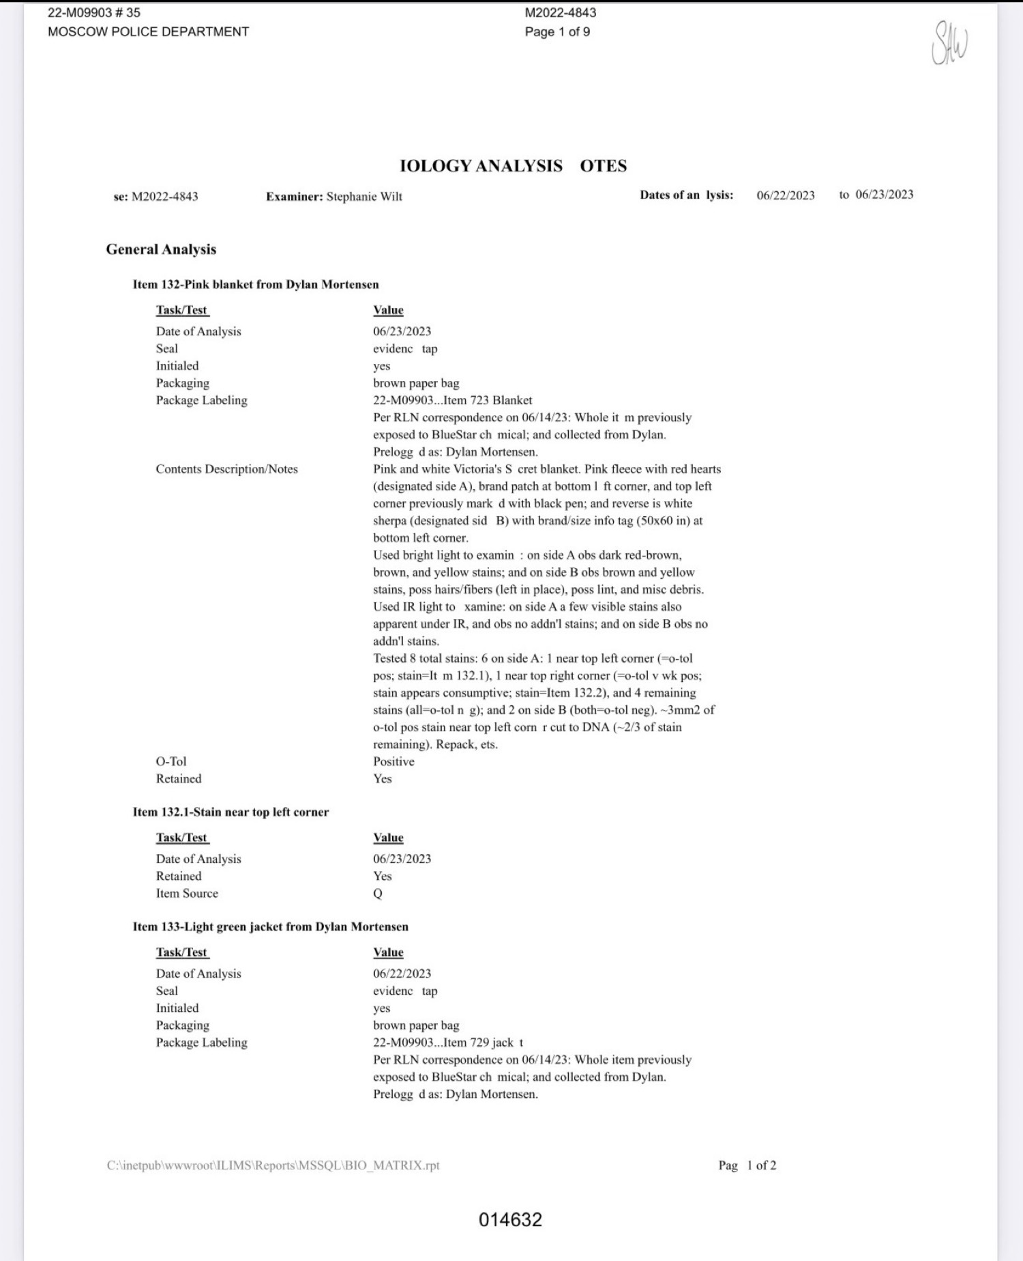

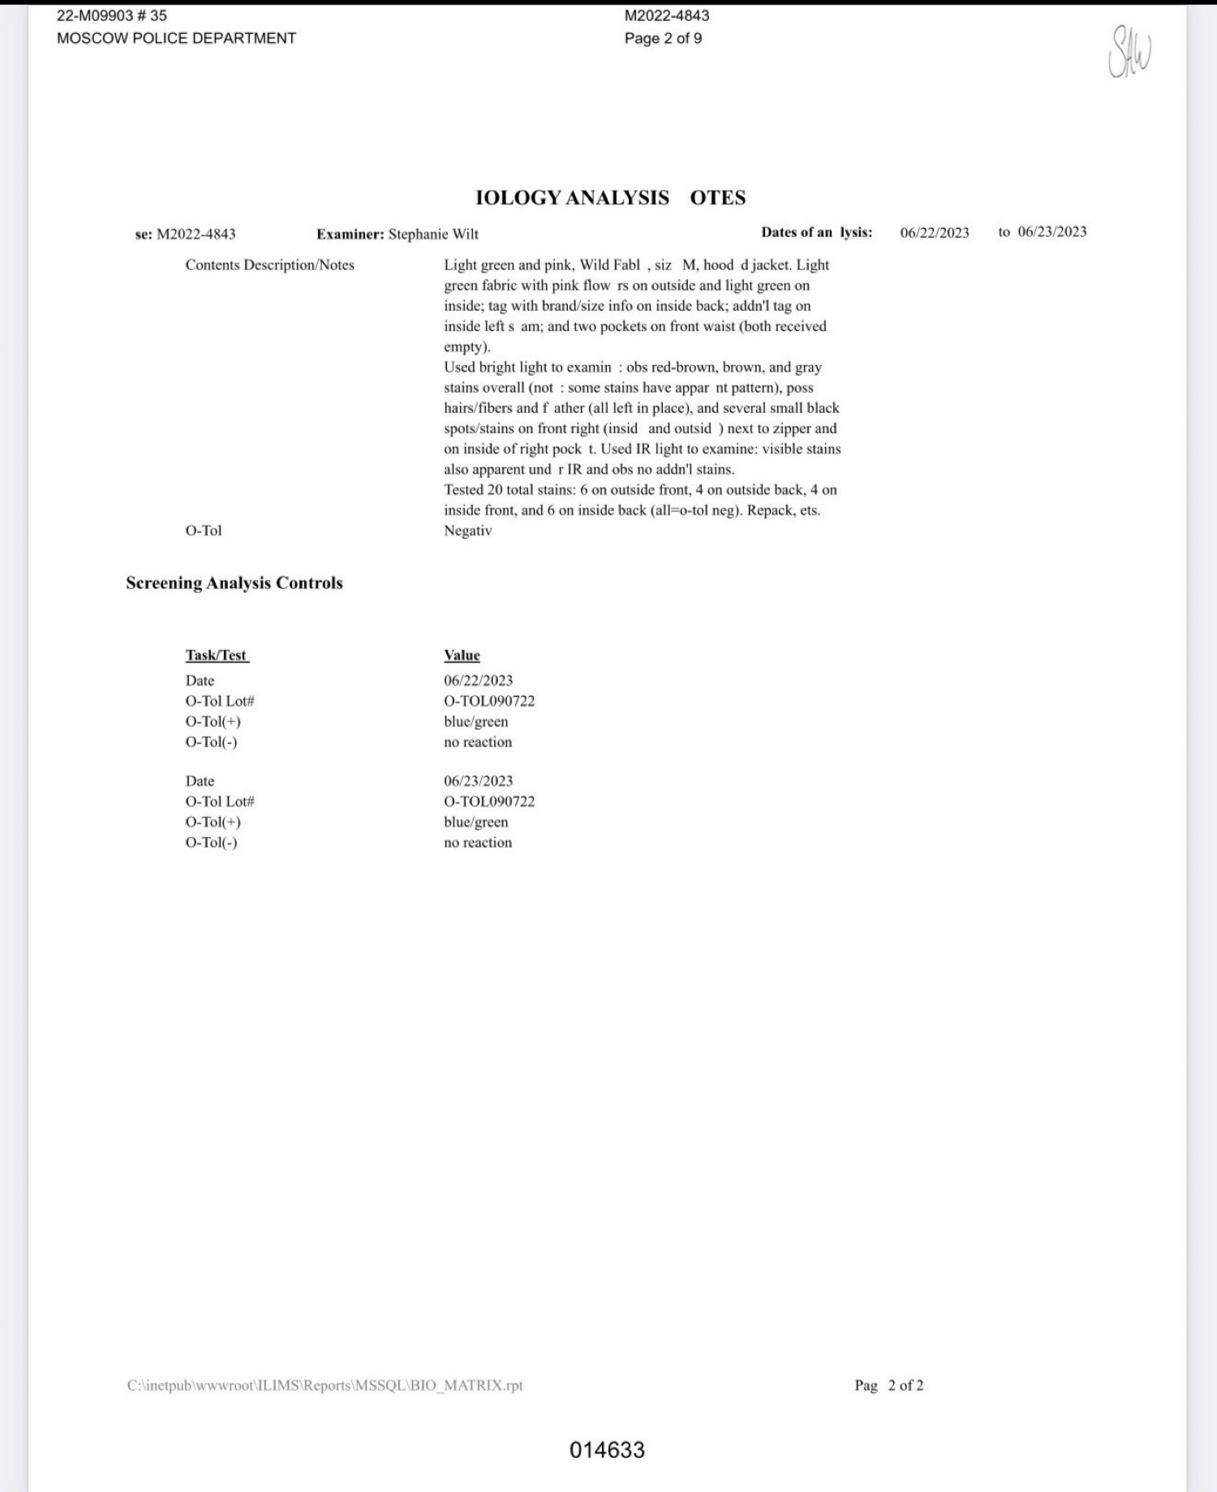

5. Lab photos of the items

Blanket 132.1 close-up cut to DNA — page 5 / 014636
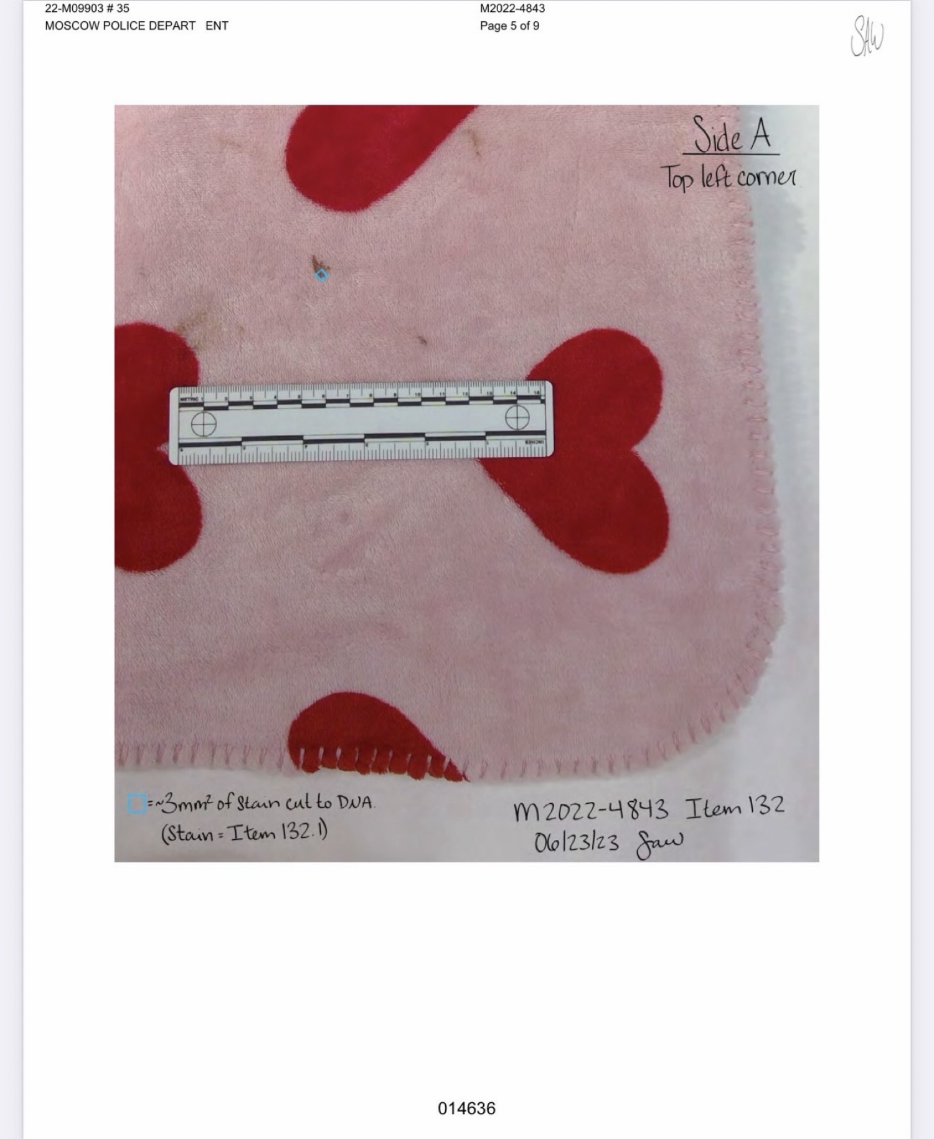

Jacket OUTSIDE BACK — page 7 / 014638
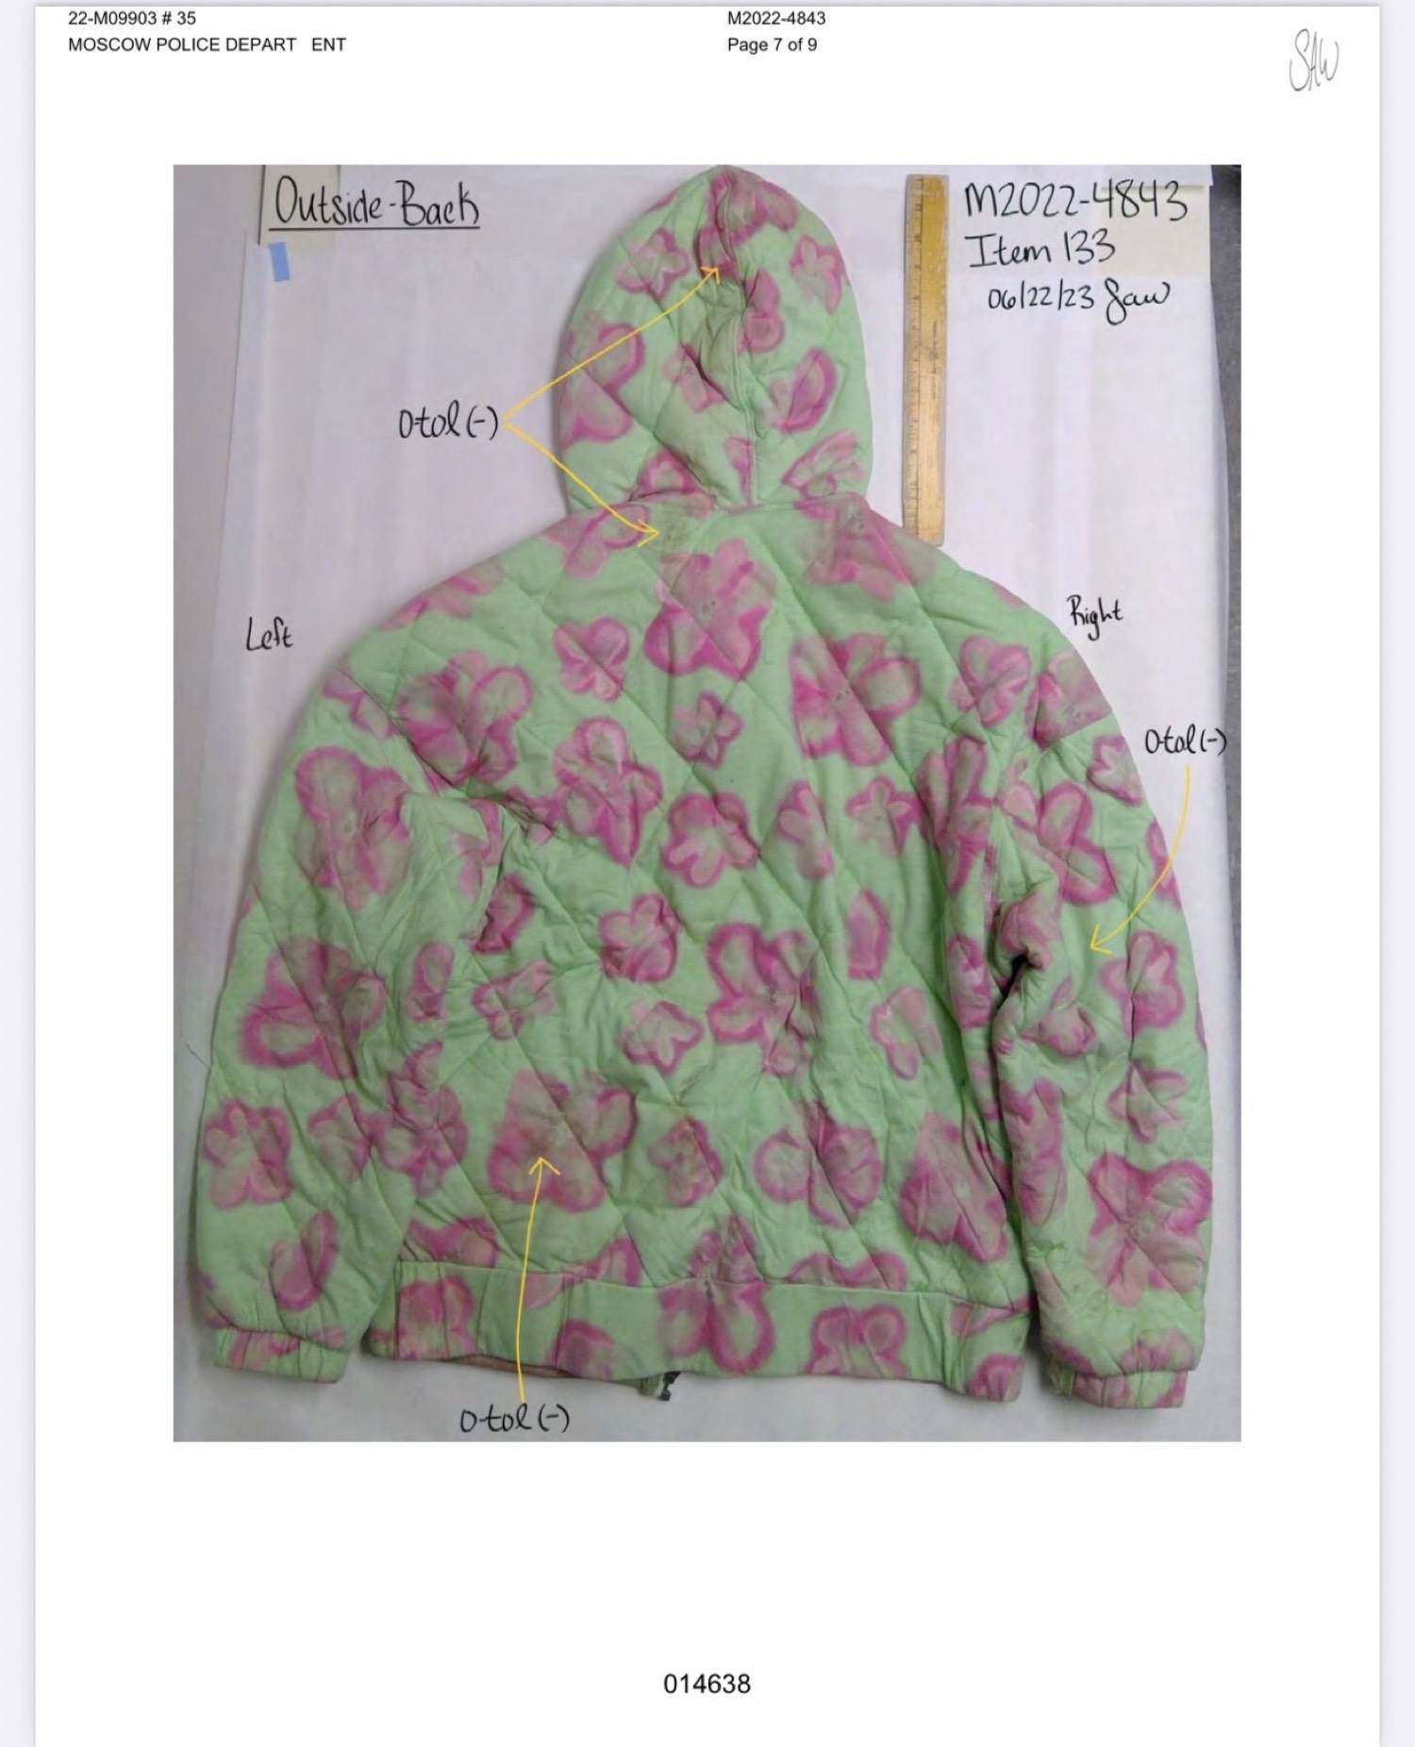

Jacket INSIDE FRONT — page 8 / 014639
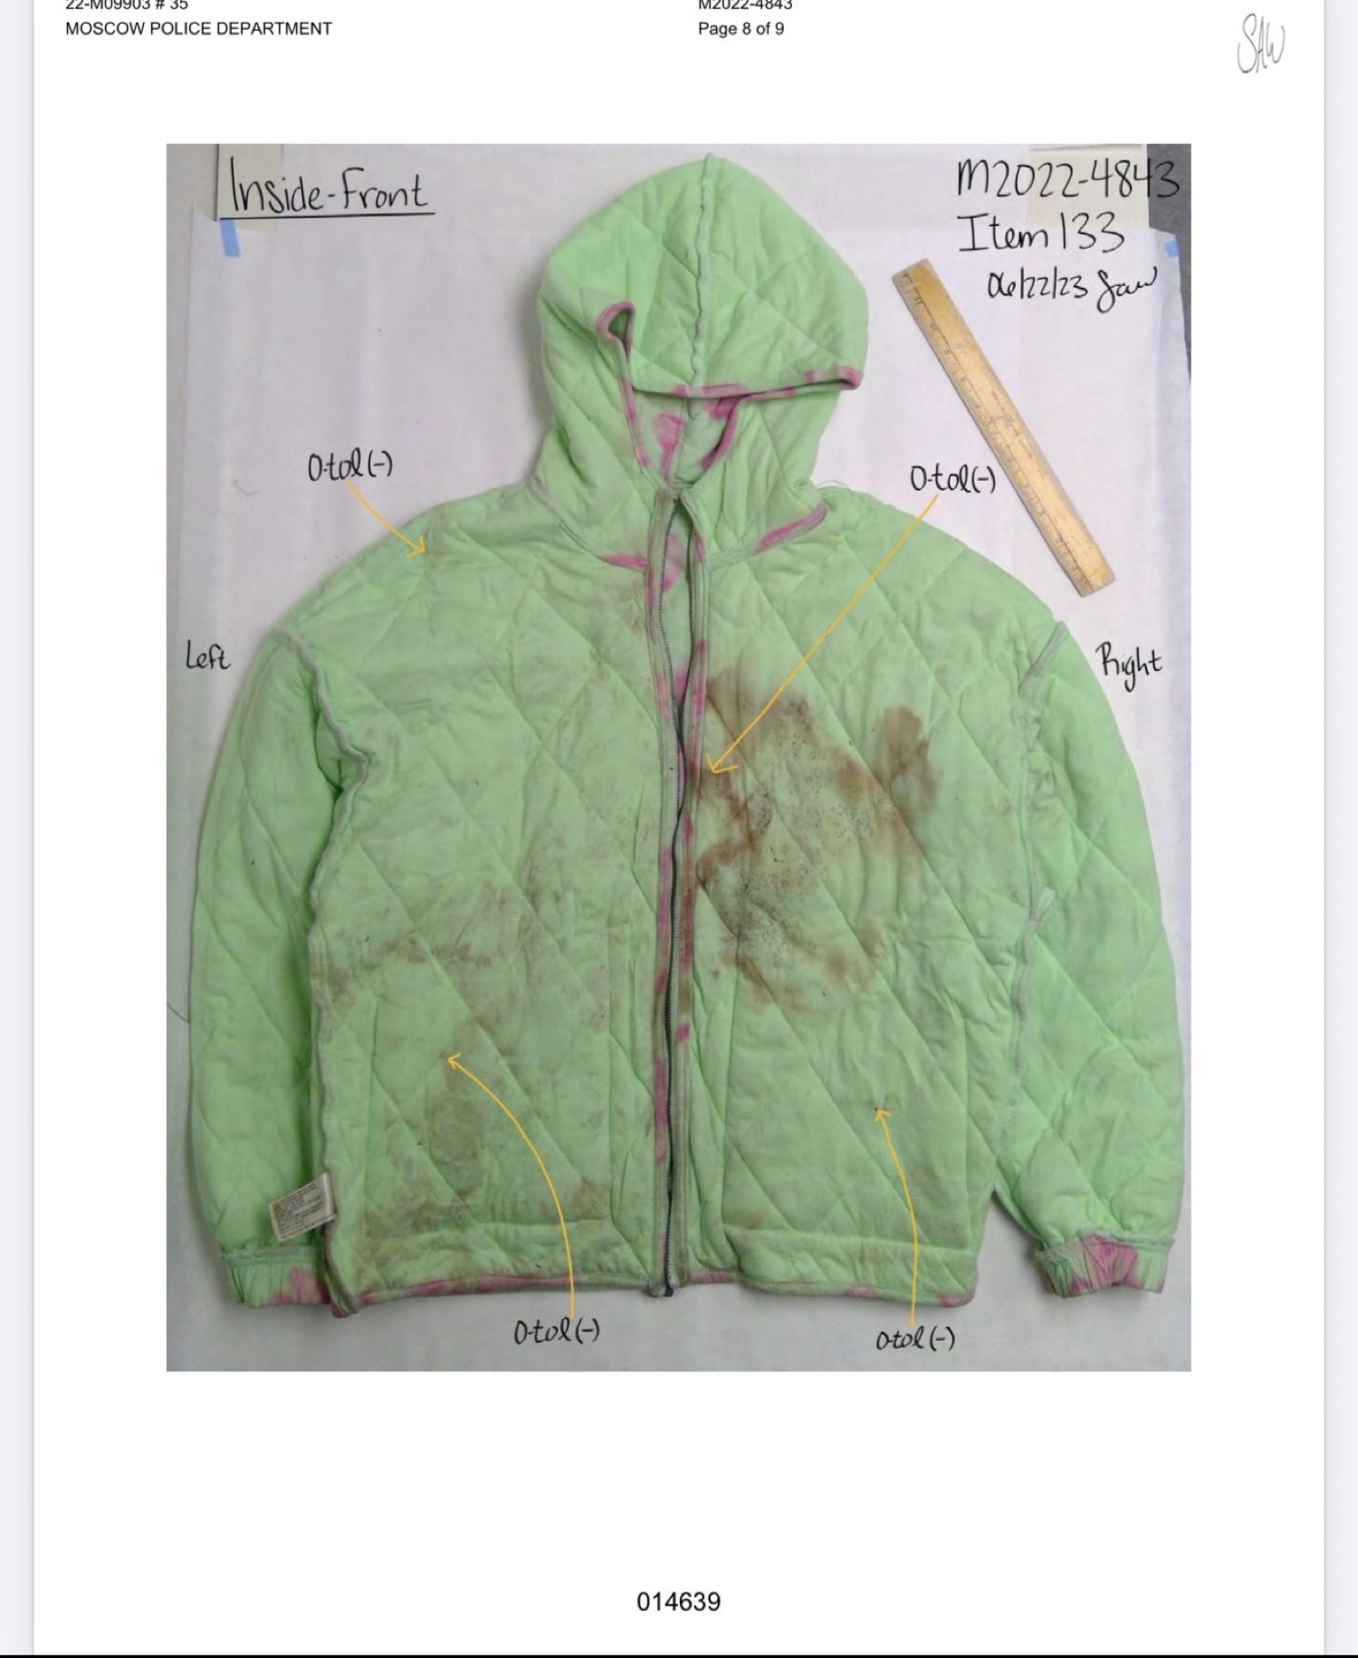

Jacket INSIDE BACK — page 9 / 014640
